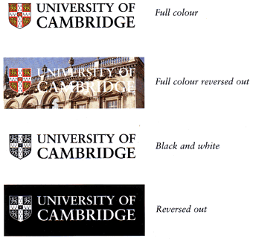DATA TRANSFER AGREEMENT

EPIC NORFOLK

APPLICATION FORM

|  |  |  |
| --- | --- | --- |
|  | **Provider (Cambridge)** | The Chancellor, Masters and Scholars of the University of Cambridge of The Old Schools, Trinity Lane, Cambridge CB2 1TN, UK |
|  | **Provider Scientist** | Professor Nick Wareham |
|  | **Recipient** | [INSERT RECIPIENT LEGAL ENTITY] of [INSERT ADDRESS] |
|  | **Recipient Scientist** | [INSERT RECIPIENT ACADEMIC] |
|  | **Data** | as defined in clause 1.1, and detailed in the EPIC-Norfolk Data Request Form which has been approved by the EPIC-Norfolk Management Committee and is provided in Appendix B |
|  | **Research Purpose** | means the proposed analysis by the Recipient. |
|  |  | Further information on the study and purpose of the data transfer is provided in the Data Request form at Appendix B. |
|  |  | The Recipient wishes to acquire and use the Data for the Research Purpose |
|  | **Term** | Cambridge is willing to provide the Data to the Recipient for the Research Purpose from the date of execution of this Agreement for a period of 3 years. |
|  | **Publication**  **Acknowledgement** | “The EPIC-Norfolk study (DOI 10.22025/2019.10.105.00004) has received funding from the Medical Research Council (MR/N003284/1 MC-UU_12015/1 and MC_UU_00006/1) and Cancer Research UK (C864/A14136). The genetics work in the EPIC-Norfolk study was funded by the Medical Research Council (MC_PC_13048). We are grateful to all the participants who have been part of the project and to the many members of the study teams at the University of Cambridge who have enabled this research.” |
|  | **Cost** | The data is provided at no cost. |

Cambridge agrees to provide and the Recipient agrees to receive and use the Data for the Research Project in accordance with the terms and conditions set out in this Agreement.

**PLEASE NOTE: THIS IS A LEGALLY BINDING CONTRACT**

**BETWEEN THE UNIVERSITY OF CAMBRIDGE AND THE RECIPIENT**

The signatory from the Recipient must have authority to sign on behalf of their institution, thus creating legal obligations in respect of the Recipient.

People who usually **have** such authority include:

* Directors
* Heads of Legal
* Heads of Finance
* Technology Transfer Associates

People who usually **don’t have** such authority include:

* Recipient’s Principal Investigator
* Recipient’s Scientist
* Post-docs
* Students

Please ensure that the address included for the Recipient is in fact the registered address of the contracting Legal Entity, and **not** the lab or department of the Recipient Scientist.

AGREED by the Parties through their authorised signatories:

|  |  |  |  |  |
| --- | --- | --- | --- | --- |
| For and on behalf of  **The Chancellors, Masters and Scholars of the University of Cambridge** |  | For and on behalf of [INSERT RECIPIENT] |  | Read and understood by theRecipient Scientist |
|  |  |  |  |  |
| Signed |  | Signed |  | Signed |
|  |  |  |  |  |
| Print name |  | Print name |  | Print name |
|  |  |  |  |  |
| Title |  | Title |  | Title |
|  |  |  |  |  |
| Date |  | Date |  | Date |











